**HTML | <audio> src Attribute**

Last Updated : 15 Jul, 2022

The **HTML <audio> src attribute** is used to specify the URL of the audio files. We should use the Mp3 file for play the audio in the Internet Explorer and Safari Browsers. The source element can be used to add audio files to a webpage to work in all the Browsers.

**Syntax:**

<audio src="URL">

**Attribute Values:** It contains single value URL which specifies the URL of the audio files. There are two types of URL link which are listed below:

* **Absolute URL:**It points to another webpage.
* **Relative URL:** It points to other files of the same web page.

Below example illustrates the <audio> src attribute in HTML:

**Example:**

* html

|  |
| --- |
| <!DOCTYPE html>  <html>    <head>      <title>          HTML audio src Attribute      </title>  </head>    <body style="text-align:center;">        <h1>GeeksforGeeks</h1>        <h2>          HTML audio src Attribute      </h2>        <audio controls muted>          <source src="GFG.mp3" type="audio/mp3">          <source src="GFG.ogg" type="audio/ogg">      </audio>  </body>    </html> |

**Output:**

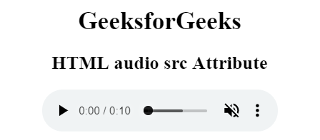

**Supported Browsers:** The bro